1. In the United States Congress there are two houses, the House of Representatives and the Senate. You are going to draw an E-R diagram to represent the House of Representatives. (19 points)

Here is what you need to know:

a. Each member of the House of Representatives represents exactly one district in one state. Each representative represents a political party of which we have many. Longevity of position affects committee assignments.

b. The states are grouped into regions such as West, South, Midwest, Southeast, MidAtlantic, and Northeast.

c. Each member of the House has the opportunity to sponsor a bill. S/he can do this alone or with other members of the House. Every bill has a unique number (HR 432). A record is kept of when a vote is taken and the outcome of the vote.

d. Each member of the House has the opportunity to vote on bills presented to the full House. A record is kept of how each person voted.

e. There are 435 members of the House

f. States have at least 1 representative and the most currently is 52.

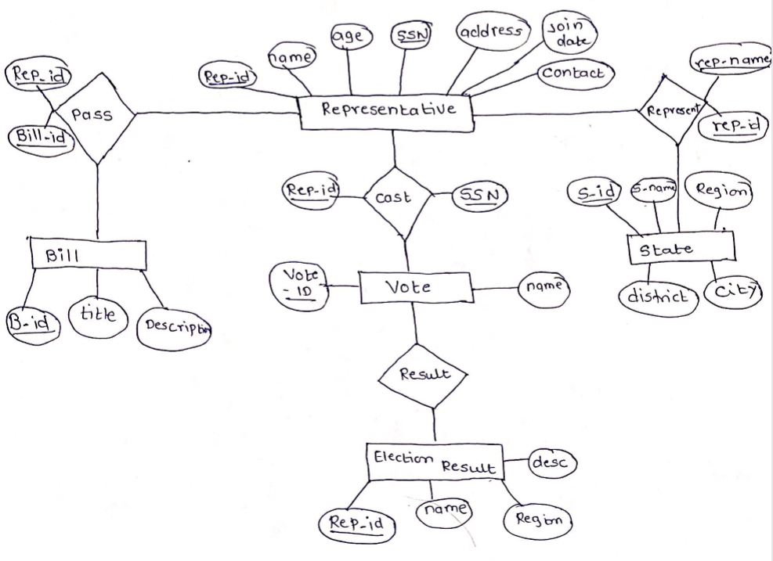

2. Composite and multi-valued attributes can be nested to any number of levels. Suppose we want to design an attribute for a STUDENT entity type to keep track of previous college education. Such an attribute will have one entry for each college previously attended, and this entry is composed of: college name, start and end dates, degree entries (degrees awarded at that college, if any), and transcript entries (courses completed at that college, if any). Each degree entry is formed of degree name and the month and year it was awarded, and each transcript entry is formed of a course name, semester, year, and grade. Design an attribute, attendance, to be one of the attributes of the entity set STUDENT and it is to hold all of attendance information stated above. (19 points)

**Student Entity:**

Student_Id

Student Name (Stud_id,first_name,m_name,last_name)

DOB (stud_id,Age,mont,date,year)

Department (dept_id, dept_name)

Attendance

Degree(stud_id,degree_name,college_name, duration(start Date,end_date))

Transcript (sem, year, total_credits, course (c_id, c_name, credit, grade, GPA))

3. Draw an E-R diagram for only the attendance portion of the STUDENT. Think about how composite and multivalued attributes are represented. Do this using only strong entity sets, weak entity sets and relationship sets. You may use software or draw your diagram by hand. If you draw it by hand, please scan into a pdf file before you upload. It would be even better if you could cut and paste it into your homework document. (12 points)

